**Innovation and Entrepreneurship**

25/04/2024: Final Poster Submission on Google Classroom

25/04/2024: 5M pitching (1-2people) (4.15-5pm)

25/04/2024: 20M File Submission

01/05/2024: Panel Evaluation 11.00am-1.00pm(ours will be towards the end as CO16 is the last group for this time slot)

**FINAL POSTER**:

**Examples:-**

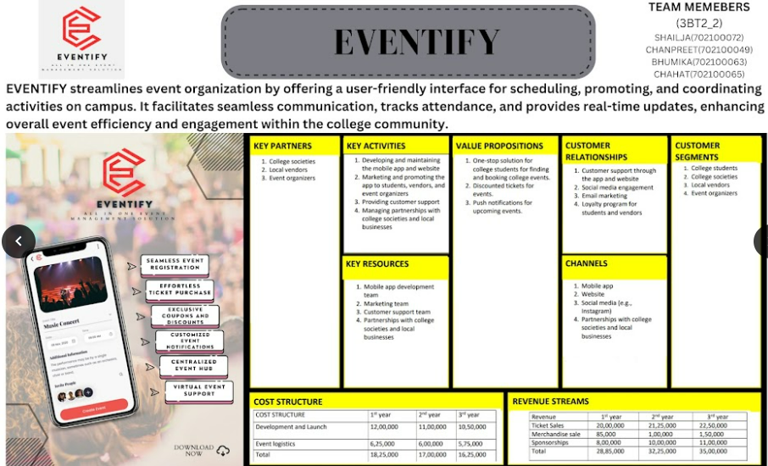

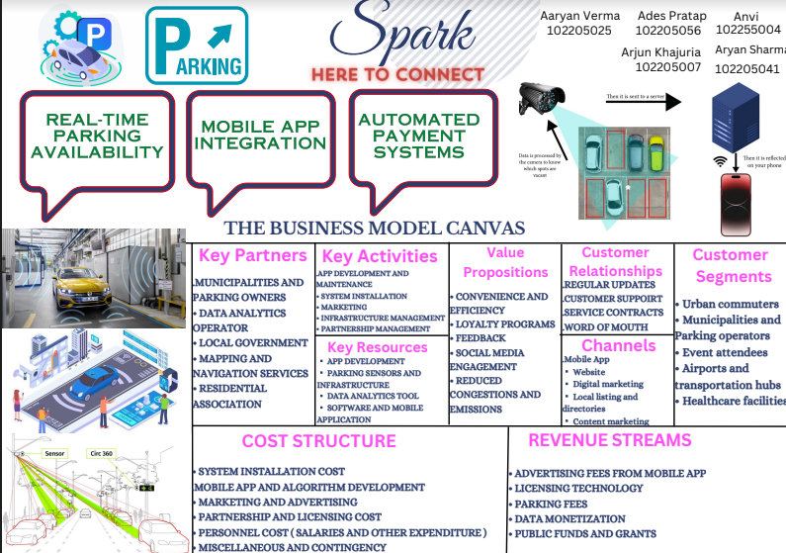

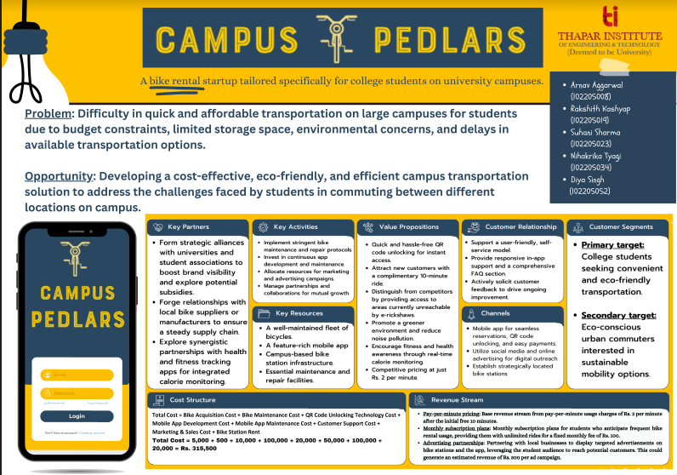

**KEY POINTS:**

* The poster should be printed in landscape format. More than A2 size or (18 x 24 in)
* It must have the TIET logo in the top left corner
* It must have the correct group number (for example 3COY_x, where Y is the group number and x stands for the sub group number), names of all team members with roll numbers on the top right corner
* It must have your team’s name in top centre.  You may add a company logo.
* A tag line or 2 – line brief intro of your business solution will be an advantage during the Pitching
* Poster is not only the BMC.  You should add some informative graphics (30-40%) along with BMC(60-70%)
* The Cost and Revenue structure blocks should have the financial information in Indian Rupees per
* Unit or per Month. Preferably tables can be used in the cost and revenue blocks in BMC
* You may add your creativity, colours to make it more attractive.

**PITCHING**

* Slides: <https://docs.google.com/presentation/d/1pSQmTywf0tOH4rzzxon1d8eybvZkR5GMncWcNkgGi0w/edit?usp=sharing>
* Marks: 5M
* Time: 3-5mins
* No reference material to be used. Learn everything you want to say
* Pitch should end with a question asking for the investor’s affirmation of meeting at a particular date, time and place.
* Classroom: The following lab activity, 'pitching,' shall be carried out in that lab session and will carry five marks. ''Pitching'' means asking the investors for funds and fixing the next appointment. The way to carry out the activity was explained in the lab session. PowerPoint resources on the 'Pitching activity' are attached so you can make a pitch and practice it. 1 or 2 students should make the pitch to the assumed investors about the business idea and cover all points as mentioned in the attached slide.  The pitch should end with a question asking for the investor's affirmation of meeting again at a particular date, time, and place.  
  Please note the following point carefully, as I emphasized in the lab session. The students SHALL NOT USE ANY POWERPOINT SLIDES or ANY OTHER AID. They should speak directly and are not expected to read out from any source. However, some points may be written and kept as a backup. A pitch is considered as well executed when it is not read out. The students are expected to make eye contact and speak.    
  Clarity and relevance of the pitch, energy, passion, conviction, the creativity of the pitcher(s), and the use of examples and numbers are essential. The time limit is 3-5 minutes, preferably around 4 minutes.

**FINAL REPORT**

* 20M
* All details in attached File